**REPUBLIC OF BURUNDI**

MINISTRY OF NATIONAL EDUCATION AND RESEARCH

SCIENTIFIC

BUJUMBURA INTERNATIONAL UNIVERSITY



**FACULTY OF SCIENCE AND TECHNOLOGY**

**Option: Software Engineering**

By

Aimable MUNYESHAKA

BIU-06-157

**Under the supervision:**

MSc Peter Abraham HAVYARIMANA

Bujumbura, November 2022

**INTERNSHIP REPORT CARRIED OUT WITHIN MINEVAM KIGOBE**

**From February 1st, 2022 to April 29th, 2022**

**Theme: Analysis, Design and Implementation of a web application for the management of a church: case of MINEVAM Kigobe**

**STATEMENT**

This internship report is my original work and has not been submitted elsewhere for graduation.

Signature: ……………………………… Date: ………….

Aimable MUNYESHAKA

BIU-06-157

**APPROVAL**

This internship report has been submitted for presentation with the approval of the Supervisor.

Signature: …………………………… Date: ………………

MSc Peter Abraham HAVYARIMANA

**ACKNOWLEDGMENT**

I would like to thank all the people who contributed to the success of my internship and who helped me during the writing of this report.

First of all, I would like to sincerely thank my internship supervisor, MSc Peter Abraham HAVYARIMANA: dean of computer and network maintenance institute at Grate lakes University and CEO of Intelligent Technology Corporation; the time he devoted to my supervision.

I thank all pastors and core members of MINEVAM Kigobe Church for their welcome, sharing with their expertise on a daily basis.

I would like to thank my parents: Alexis KANYABIGO and Médiatrice NSENGIYUMVA, my brothers and sisters, and friends.

# **ACRONYMS AND ABBREVIATIONS**

BIU : Bujumbura International University

CEO : Chief Executive Officer

CPU : Central Processing Unit

CSS : Cascading Style Sheets

GB : Giga Byte

HP : Hewlett Packard

HTML : Hypertext Markup Language

MINEVAM : (Ministère d’Evangélisation en Afrique et dans le Monde): Ministry of

Evangelization in Africa and in the World

MySQL : My Structured Query Language

SQL : Structured Query Language

UML : Unified Modeling Language

WAMP : Windows, Apache, MySQL and PHP

# **FIGURES**

Figure 1: MINEVAM Kigobe Location 4

Figure 2 : Organization chart 9

Figure 3: Use Case diagram 15

Figure 4: Class diagram 16

Figure 5: Sequence diagram 17

Figure 6: Activity diagram 18

Figure 7: different side for login 20

Figure 8: Login form 21

Figure 9: New member registration 22

Figure 10: Cell Report 23

Figure 11: Family report 24

Figure 12: Zone report 25

Figure 13: District Report 26

Figure 14: Admin dashboard 27

Figure 15: List of users _ admin side 27

Figure 16: List of come period of new member (promotion) 28

Figure 17: List of members 28

Figure 18: Form of add district 29

Figure 19: List of districts 29

Figure 20: Form of change district 30

Figure 21: Delete district 30

Figure 22: list of district report 31

Figure 23: List of zones 31

Figure 24: List of zone report 32

Figure 25: List of families 32

Figure 26: List of family report 33

Figure 27: List of cell host 33

Figure 28: List of cells 34

Figure 29: List of cell member attendances 34

Figure 30: List of cell report 35

Figure 31: List of income 35

Figure 32: Form of add income 36

Figure 33: Form of change income 36

Figure 34: Delete income 37

Figure 35: List of outcomes 37

Figure 36: List of beneficiaries 38

Figure 37: List of outcome type 38

Figure 38: List departments 39

Figure 39: List of department members 39

Figure 40: List of categories 40

**Table of contents**

ACRONYMS AND ABBREVIATIONS iv

FIGURES v

CHAPTER I: GENERAL INTRODUCTION 1

I.1. Reference of the training plan and connection with the internship 1

I.2. Reason for doing this internship 1

I.3. Nature of the organization where the internship was carried out. 1

I.4. Reason for choosing the specific organization where the internship was carried out. 1

I.5. Main activity of the organization 2

I.6. Outline of the internship report 2

CHAPITER II: DESCRIPTION OF MINEVAM KIGOBE 3

II.1. Organization History 3

II.2. Geographical location of the organization 4

II.3. Legal framework of the organization 4

II.4. Organizational Vision 4

II.5. Organizational Mission 5

II.6. Organizational Objective 5

II.7. Organizational Values 5

II.8. Future prospects of the organization 5

II.9. Services offered by the organization 5

CHAPTER III: ANALYSIS AND DESCRIPTION OF ACTIVITIES 10

III.1. Presentation of reception services and planning of activities during the internship period 10

III.2. Description of the activities carried out 10

III.3. Correlation between the reality on the ground and the theoretical lessons learned in class: 10

III.4. Description of the problem observed 11

III.5. Analysis and criticism of the existing system 11

III.6. Suggested solutions to this problem. 12

CHAPTER IV: SYSTEM MODELING AND PRESENTATION OF THE DEVELOPED APPLICATION 13

IV.1. Explanation of choice of UML 13

IV.2. Advantages of UML 13

IV.3. Overview of some UML diagrams 13

IV.3.1. Use Case diagram 13

IV.3.2. Class diagram 13

IV.3.3. Sequence diagram 14

IV.3.4. Activity diagram 14

IV.4. Modeling of the proposed system 14

IV.5. Presentation of application 18

IV.5.1. Used tools 18

IV.5.2. User interface description 20

IV.5.3 Advantages of application 40

CHAPITRE V: GENERAL CONCLUSION AND SUGGESTIONS 41

V.1. General conclusion 41

V.1.1. Critical assessment of the progress of the internship 41

V.1.2. Critical appraisal of the observed problem 41

V.2. Suggestions 41

REFERENCES 42

# **CHAPTER I: GENERAL INTRODUCTION**

## **I.1. Reference of the training plan and connection with the internship**

First day of my internship, I talk with a Pastor of MINEVAM Kigobe Church, and he described me the information system. I explored the existing system: desktop application that they are using. He described all the activities of the church.

## **I.2. Reason for doing this internship**

* Internships are generally thought of to be reserved for university students looking to gain experience in a particular field. However, a wide disposition of people can benefit from Training Internships in order to receive real world experience and develop their skills.
* Some internship is used to allow individuals to perform scientific research while others are specifically designed to allow people to gain first-hand experience working.
* Using internships is a great way to build your summary and develop skills that can be useful for future jobs.

## **I.3. Nature of the organization where the internship was carried out.**

The Church is an organization of religious believers, the new covenant people of God, rooted in the promises to Israel and inaugurated by the Holy Spirit, which refers both to all believers in Jesus Christ, both living and dead, and to individual local gatherings of believers.

## **I.4. Reason for choosing the specific organization where the internship was carried out.**

One day I went in the office of Pastor of MINEVAM Kigobe then I saw many boxes and I thought those are for storing data from papers. After I saw other problem like reporting cell activity for cells department. The idea of digitalization of that church came in my mind and I made the decision to do my internship at MINEVAM Kigobe as software student.

## **I.5. Main activity of the organization**

The main activity of the church is to promote reconciliation through the Great Commission of Jesus Christ: consist of preaching, announcing and testifying, making disciples and bearing witness. That will be done through different departments. Staff talk each other, talk with cells leaders and report how church is growing up: how members continue to grow up spiritually.

## **I.6. Outline of the internship report**

I was given the internship of three months in church called MINEVAM Kigobe. The plan of the activities carried out during the internship is as follows:

* From February 1st, 2022 to February 25th,2022: It was more about contact, I asked many questions to really understand the management of the church and that helped me to make the analysis of the existing system and make UML diagrams
* From February 28th, 2022 to April 1st, 2022: I started to develop the application trying to resolve the problem
* From April 4th, 2022 to February 29th, 2022: I continued to develop the application and starting test for making sure that I answered to the problem.

# **CHAPITER II: DESCRIPTION OF MINEVAM KIGOBE**

## **II.1. Organization History**

One of the Burundian missionaries named Elias GAHOMERA created the MINEVAM Church in 1989 in the city of Kinshasa in Democratic Republic of Congo. As its name suggests, its vision was to spread the gospel of salvation to all nations. It was in 1992 that he started in Burundi and in 1995 in Rwanda. MINEVAM continues to be implanted in the different countries of Africa even in other continents. Currently they have churches in Tanzania, Uganda and India an exception for other countries in other continents.

The MINEVAM Kigobe Church is one of the parishes forming the community of MINEVAM Churches in Burundi. The MINEVAM Kigobe parish was opened in June 2003 by a group of 14 young people from the so-called Mount of Olives parish in downtown Bujumbura. However, it had opened in 1998 and had to close because of the inaccessibility of the surrounding populations to the place of worship and because of the security situation that prevailed at the time. Since then, she worked under the direct leadership of the mother parish from 2003 until 2006 when Pastor MUGISHA Diamonde was ordained and was finally called to other functions. It was only at the end of 2007 that the parish saw the ordination of a new Pastor in the person of NINGANZA Aimé-Prosper until today Senior Pastor of the Parish. Since September 2018, the Church has had a Council of Church Leaders, including 3 pastors already ordained. The Church has continued to grow from a young majority to half-adult, half-young and its membership numbers about 1,100 peoples. [5]

## **II.2. Geographical location of the organization**

MINEVAM Kigobe parish is located at Kigobe quarter in Bujumbura Burundi.

Mwezi Gisabo Boulevard (In front of Kamenge Campus, Bujumbura)

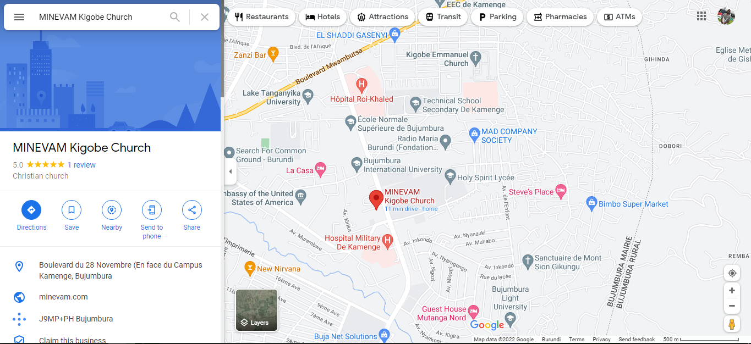

Figure 1: MINEVAM Kigobe Location

## **II.3. Legal framework of the organization**

Organization created under ministerial order of October 10th, 1992 no205.01/431 with name of (Ministère International d’évangélisation en Afrique et dans le monde: MINEVAM): International Ministry of evangelisation in Africa and in the world. That order change to another of January 19th, 2015 with name of (Eglise pour les ministères d’évangélisation en Afrique et dans le monde): Church for ministries of evangelisation in Africa and in the world under ministerial order no 530/099.

## **II.4. Organizational Vision**

The church MINEVAM Kigobe wants to be a family of families united by worshiping God, growing in the likeness of Christ, serving others and reaching the world.

## **II.5. Organizational Mission**

Based on the great commandment and the Great Commission, the MINEVAM Kigobe church aims to bring lost souls back to Jesus Christ as members of his family and his true worshippers, develop their maturity in the likeness of Christ, equip them in life of their ministry in the body of Christ and in their holistic ministries in the world as accomplished serving leaders.

## **II.6. Organizational Objective**

The church MINEVAM Kigobe wants to be a **family** of families united by **worshiping** God, **growing** in the likeness of Christ, **serving** others and **reaching the world** (Family, Worship, Maturity, Ministry, Mission)

## **II.7. Organizational Values**

(DRISAH: Discipline, Redevabilité, Integrité, Service, Amour, Humilité): Discipline, Accountability, Integrity, Service, Love, Humility

## **II.8. Future prospects of the organization**

Every member will live on mission beginning locally, move members from apathetic to advocate, holistic transformation, and make a community wide movement/network of healthy churches.

## **II.9. Services offered by the organization**

Services offered to the members through departments: Cells, Mission, Sunday school, Women, Men, Youth, Communication, Compassion, Usher, choir and Intercession. [7]

1. **The Department of Cells**: Is a small family of the big family of the Church where the vision of the Church is lived: To be a family of families who worship God, believe in the likeness of Christ, serve others and reach the world. This requires that there be a time for sharing the word of God, for discovering and exercising spiritual gifts, a time for fellowship and opportunities for mutual help, times for praise and worship, moments of evangelization. It is made up of members of the church and people in the process of integration (being in the process of following the teachings preparing for baptism and reception in the great family of the church). Acts 2: 42-47, Exodus 18:13-26
2. **The mission department**: Its vision is to be people who evangelize the world and to help the whole family of the church to evangelize the world of their surroundings, their professional environment or other relations. This causes the department to help the church know the gospel message and discover missionary bridges for spreading the gospel or activities in which to invite the church to participate (Matthew 28:18-20, Luke 24:44-46, Acts 1:8)
3. **The Sunday School Department**: The church has a framework for supervising children according to the word of God and according to their gifts and aptitudes. This is the department of Sunday School: this requires the commitment of monitors and parents who work closely to help the child grow in an environment where he learns biblical and moral values that will help him have a christian education during the time of growth. All children old and new are welcome in the department (Proverbs 22:6)
4. **The women's department**: This department aims to be an edification framework for women to learn biblical values worthy of sensible women helping men in the home. All women are members by default, both members and non-members of the church. It is also a setting where women learn to serve God according to the gifts and abilities or according to the orientations of God (Genesis 2:18).
5. **The men's department**: This department has this objective: To be a framework for the edification of men to learn biblical values worthy of men who are supposed to be heads in the home. All men are members by default, members and non-members of the church. It is also a framework where men learn to serve God according to the gifts and abilities or according to the orientations of God and to help and members of his family to serve God (1 Corinthians 11:1-3).
6. **The youth department**: The youth department is a framework of supervision according to the word of God and according to the different ages. This makes it possible to develop biblical values in young people and to prepare them to better live their stages of growth and to prepare for different levels of life or different services, in particular the family, the profession, the call to serve God, etc. All young old and new, members and non-members of the church are invited to the department (1 John 2:12,14,1 Timothy 4:12).
7. **The communication department**: This department aims to facilitate the transmission of information from the church, both internally and externally. Put the sermon messages in different storage media and bring it to the attention of the public when needed. Explore the different channels of communication that can help expand the kingdom of God.
8. **The Department of Compassion**: This department allows the church to identify the widow(er) and the orphan(s) in the church in order to take decision on their eligibility to be supported by means of the funds. Church mobilizes during Holy Communion. The department regularly studies the best way to stay with the vulnerable by working closely with the administration and the family units. Members are people who have compassion at heart and who are members of the church family with a commitment shown to the heads of the department (Acts 6:1-5, Galatians 2:10, James 1:26-27)
9. **The protocol department**: It is in charge of welcoming people during the various meetings. It is in charge of the cleanliness of the place of worship or even the layout of the meeting places. Members are people who have the protocol service at heart and who are members of the family of the church with a commitment shown to the heads of the department.
10. **The choir department**: It is responsible for accompanying the church with songs during the various meetings (cults, meetings, weddings, funerals, missionary activities such as the crusades, etc.). Members are people who have the choir at heart and who are members of the family of the church with a commitment shown to the heads of the department. 1 Chronicles 15: 16, 27, 1 Kings 10: 12
11. **The department of intercession**: To bring the church (to stand in the breach) in prayer according to the different moments that the church can know or cross. Accompany the church especially in moments of worship or periods of prayer such as youth and prayers organized periodically (Ephesians 6:18, Ezekiel 3:17)

Figure below shows chart of MINEVAM Kigobe, Council Pastoral:

* Administration and finance with mission department: managed by Pastor Anaclet SABIYUMVA
* Worship with choir and intercession department: managed by Pastor Pie NGENDAKURIYO
* Family with cell, men, women, youth and Sunday school department: managed by Dr Bonaparte NIJIRAZANA
* Ministry with usher, compassion and communication department: managed by Revering Pastor Aimé Prosper NINGANZA

Figure 2 : Organization chart

# **CHAPTER III: ANALYSIS AND DESCRIPTION OF ACTIVITIES**

## **III.1. Presentation of reception services and planning of activities during the internship period**

When member want to talk with staff member comes to the office or makes a call for planning how to meet and talk or talk directly through phone. In my case, they gave me a workplace and I asked them when I have question about information system.

## **III.2. Description of the activities carried out**

Cells department has stuff of reporting how it was (cell activity). In cell department there are subgroups; cell: group of members, family: group of cells, zone: group of families and district: group of zones, where cell belongs to family, family to zone and zone to district. Then cell leader gives report to a family leader, family leader to the zone leader and the zone leader to the district leader. They showed me the forms that they are using and different old reports. The activity of the church is about to make fellowship with members, to be involved in the Great Commission so that each member shall be in mission and my activity was to understand their organization and digitalize the information system.

## **III.3. Correlation between the reality on the ground and the theoretical lessons learned in class:**

* Communication skills: that course helped me how to interact with staff from MINEVAM Kigobe
* MSI: UML object approach; that course helped me to analyse the system of the church
* Data Base Fundamentals: that course helped me to design database of the church
* Advanced Web Programming and Design: that course helped me to implement the system of the church
* Realization Project: that course helped me to collect data and use it for digitalization of the church
* Interface Human Machine: that course helped me to think about user experience and implement what is good for users
* Software engineering workshop: that course helped me to combine different technologies for one project: testing and deployment.

## **III.4. Description of the problem observed**

* The cell leader reports on a form paper, take picture and share to the whatsapp group of a family where there are all cell leaders.
* The family leader writes reports on a form paper, take picture and share to the whatsapp group of zone where there are all family leaders.
* The zone leader reports on a form paper, take picture and share to the district leader and the district leader reports to the church administration.

As a family leader, it is a problem to have cell report in real time from cell leader and have protected data; it is not centered to the church system. The same to the family leader and the zone leader.

## **III.5. Analysis and criticism of the existing system**

MINEVAM Kigobe has computer for storing data of the church, it has Desktop Software that can manage:

* User: create, read, update and delete;
* member: create, read, update and delete;
* department: create, read, update and delete department (Mission, Men, Women, Youth, Sunday school, Usher, Compassion, Communication, Intercession, choir);
* manage finance: income, beneficiary of outcome, outcome type, outcome.

As it is desktop software for using it you have to be in that place and it has not cell report functionality, family report functionality, zone report functionality, district report functionality for manage reports they use papers, take picture and share to the whatsapp group.

## **III.6. Suggested solutions to this problem.**

MINEVAM Kigobe uses system with one computer and works offline.

For suggestion: it will be very good to use web application:

* To have all managements in real time
* All statistics in real time
* It will be easy to make decisions in real time
* and they will no struggle of distance for reaching desktop software
* Cell leader will send report through application
* Family leader will send report through application
* Zone leader will send report through application
* District leader will send report through application
* It will be very easy to manage members department

There is not possibility for managing data in real time (for cell leader, family leader, zone leader, district leader and administration staff) and that affect how they make of decisions.

# **CHAPTER IV: SYSTEM MODELING AND PRESENTATION OF THE DEVELOPED APPLICATION**

## **IV.1. Explanation of choice of UML**

Unified Modeling Language (UML) is a standardized modeling language. It helps software developers visualize, construct, and document new software systems and blueprints. UML is used to create static structure diagrams based on a variety of engineering practices that have proven to be successful in the creation of complex systems. The published standards are almost 800 pages long. Historically, UML has been used to model software systems, but it's not limited to software developers. Today, UML diagrams are used to manage processes and projects.

## **IV.2. Advantages of UML**

Most-Used and Flexible, The Software Architecture Must Be Communicated Effectively, You Need to Know Only a Fraction of the Language to Use It, Abundance of UML Tools. [6]

## **IV.3. Overview of some UML diagrams**

### **IV.3.1. Use Case diagram**

Use case diagram is a behavioral UML diagram type and frequently used to analyze various systems. They enable you to visualize the different types of roles in a system and how those roles interact with the system. [1]

### **IV.3.2. Class diagram**

Class diagrams are the main building block in object-oriented modeling. They are used to show the different objects in a system, their attributes, their operations and the relationships among them. [3]

### **IV.3.3. Sequence diagram**

Sequence diagrams, commonly used by developers, model the interactions between objects in a single use case. They illustrate how the different parts of a system interact with each other to carry out a function, and the order in which the interactions occur when a particular use case is executed. In simpler words, a sequence diagram shows different parts of a system work in a ‘sequence’ to get something done. [2]

### **IV.3.4. Activity diagram**

A UML activity diagram helps to visualize a certain use case at a more detailed level. It is a behavioural diagram that illustrates the flow of activities through a system. UML activity diagrams can also be used to depict a flow of events in a business process. They can be used to examine business processes in order to identify its flow and requirements. [4]

## **IV.4. Modeling of the proposed system**

The figure below explains how MINEVAM Kigobe system will works: new member will have access to the church overview and making registration. Admin will have all permissions (manage member, manage cell, manage department, …) and can limit permissions for other admins and have some functionality as manage cell report for cell admin, manage family report for family admin, … For include arrow mains that use case with the start of include arrow will depend of use case with the end of include arrow.

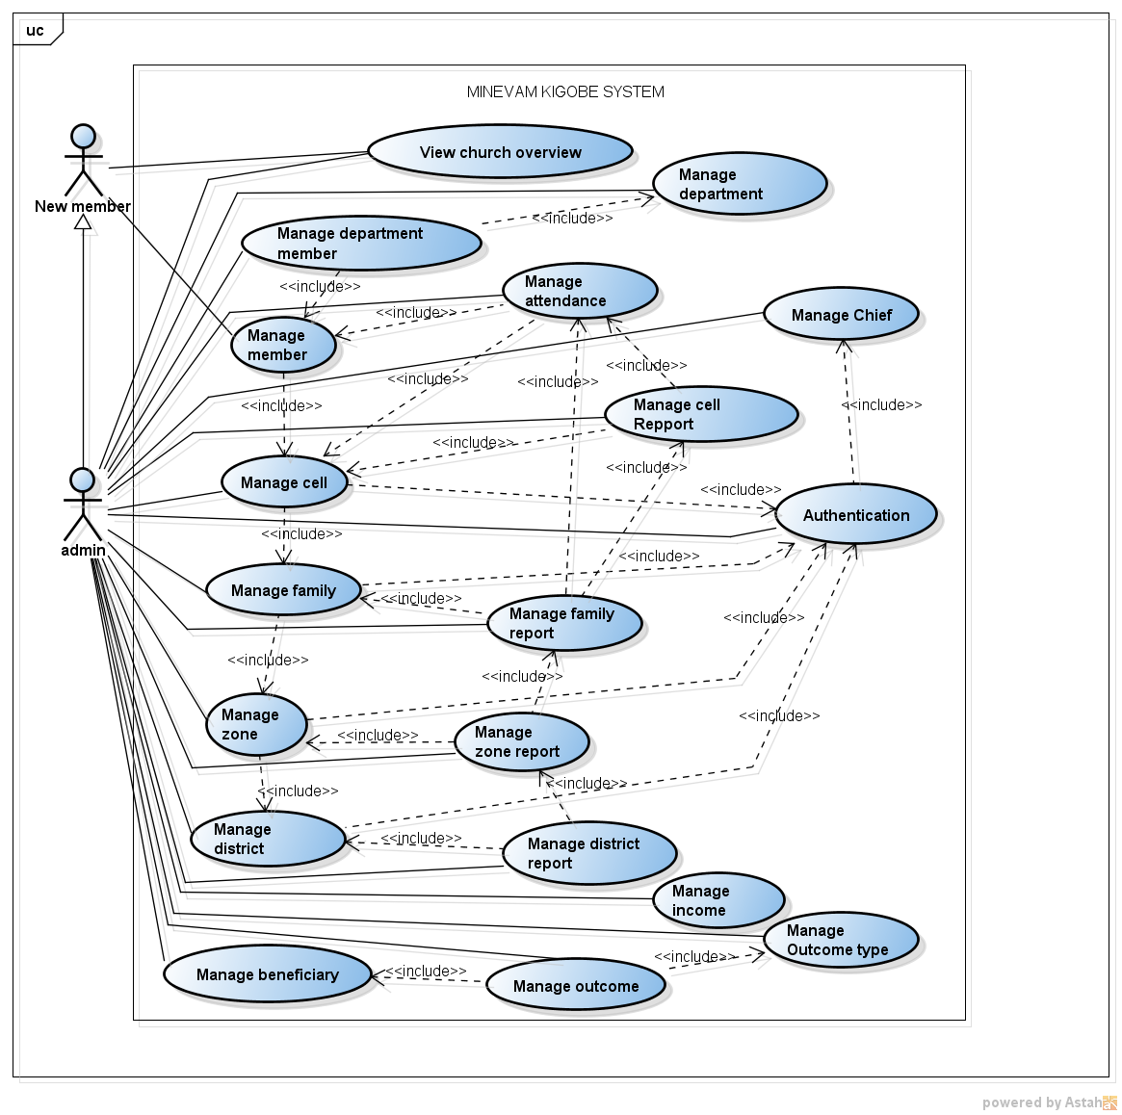

Figure 3: Use Case diagram

The figure below explains communication between class, generalization association; Admin: mother class and Chief: daughter class. Between class there are simple association with name of action and cardinality (what you can do: 1, *(many), 0 or 1, 0 or many, 1 or many); for example, chief and cell: chief manage 1 cell and cell managed with 1 chief.

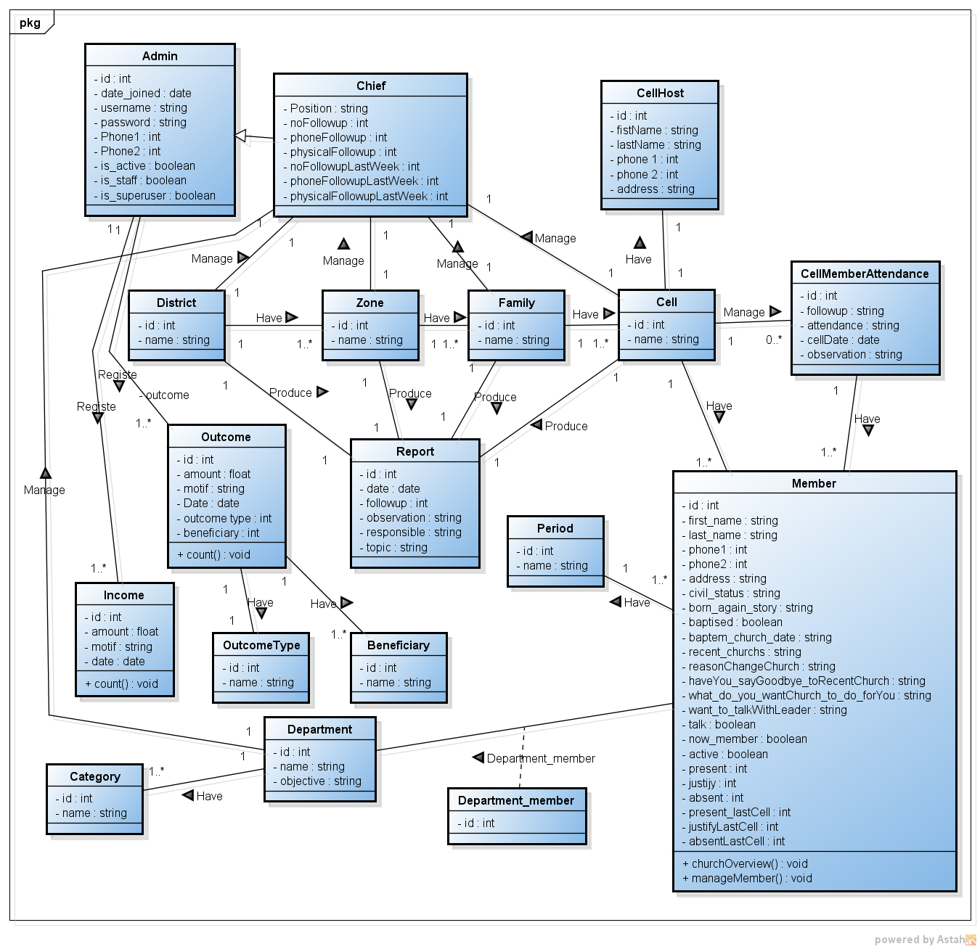

Figure 4: Class diagram

Figure below explains how admin and new member will manage system

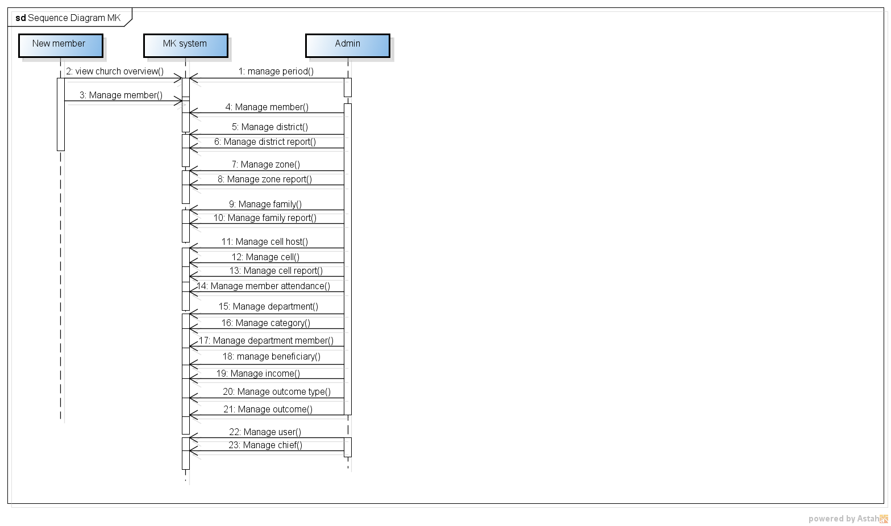

Figure 5: Sequence diagram

Figure below explains all activity of the system from login, management of different functionality of the system to logout.

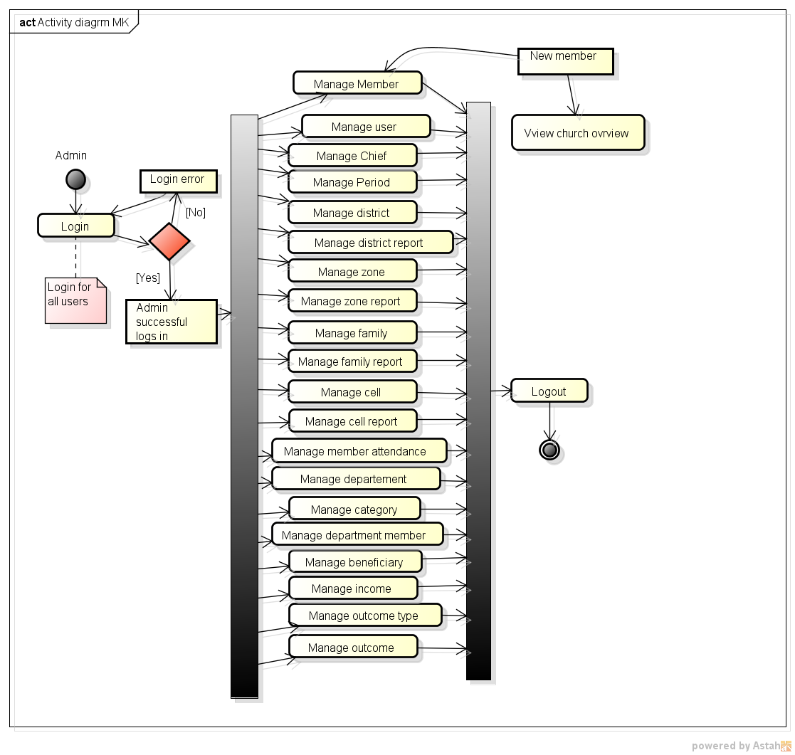

Figure 6: Activity diagram

## **IV.5. Presentation of application**

### **IV.5.1. Used tools**

* Hardware: HP: Intel(R) Core (TM) i3-2367M CPU @ 1.40GHz 1.40 GHz, 4GB of RAM, 500GB hard drive capacity, 64 bits operating system, x64 processor
* Software:
* Window 10,
* Astah community: Formerly called Jude, Astah is a UML modeling tool created by the Japanese company ChangeVision1. It works with the Java runtime environment. The name comes from the acronym Java and UML developers' environment. Astah is a proprietary software that was distributed for free in a "community" version. The software is now subject to a trial period and then to the obligation to buy a user license),
* Python: high level programming language used in many domains of development as desktop application, mobile application, machine leaning, web development, ...
* Django: full stack framework of python,
* HTML: Hypertext markup language designed to represent web pages,
* CSS: Cascading Style Sheets is the language that we use to style a web page. It describes how HTML elements are to be displayed on screen,
* JavaScript: it’s a scripting language mainly used in interactive web pages and as such is an essential part of web applications. Along with HTML and CSS, JavaScript is at the heart of the languages used by web developers.
* Bootstrap is a free and open-source CSS framework directed at responsive, mobile-first front-end web development. It contains HTML, CSS and JavaScript-based design templates for typography, forms, buttons, navigation, and other interface components.
* WAMP is an acronym that stands for Windows, Apache, MySQL, and PHP. It’s a software stack which means installing WAMP installs Apache, MySQL, and PHP on your operating system (Windows in the case of WAMP). WampServer (formerly WAMP5) is a WAMP-like web development platform, allowing to run locally (without having to connect to an external server) PHP scripts. WampServer is not in itself a software, but an environment including three servers (Apache, MySQL and MariaDB), a script interpreter (PHP), as well as phpMyAdmin for the Web administration of MySQL databases.
* IP address: Internet protocol, I used 127.0.0.1 localHost
* Port: 8000

I used Bootstrap 5 for frontend, Django for backend and mysql for database. [11]

### **IV.5.2. User interface description**

For access admin side you have to add /mk to the main link (or domain name) and access login form for admin side, it is for security lesson. Admin includes pastors of MINEVAM Kigobe and office staff.

Figure below shows list of different side of cell departments who are going to report cell activity.

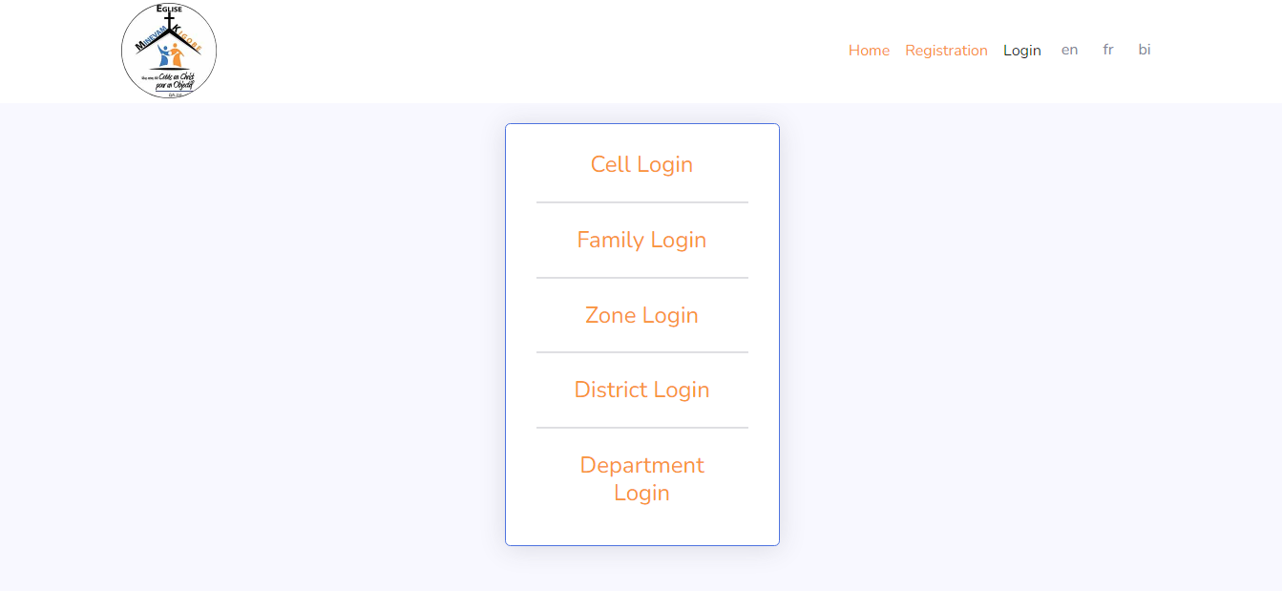

Figure 7: different side for login

Figure below shows login form for accessing the system

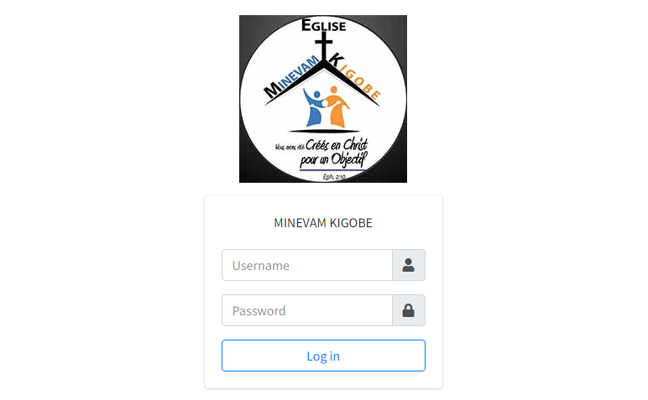

Figure 8: Login form

Figure below shows registration form where new members will input data for describe themselves

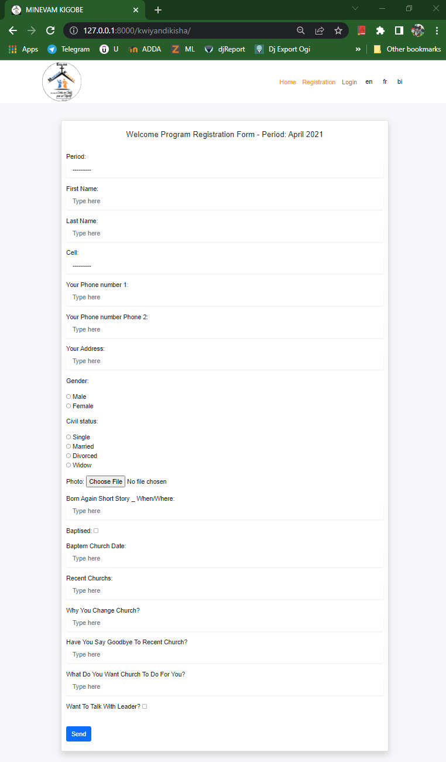

Figure 9: New member registration

Figure below shows form for cell reporting of specific cell: cell will contain own cell members.

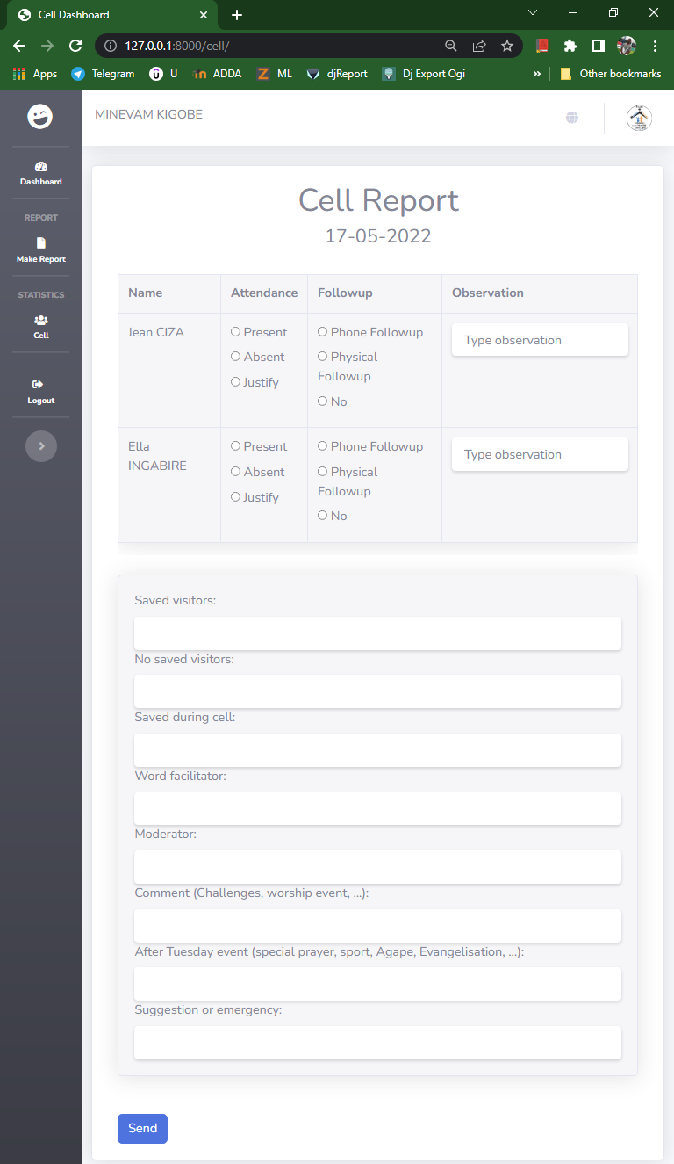

Figure 10: Cell Report

Figure below shows form for family reporting of specific family and analytics of each cell that belong to the family.

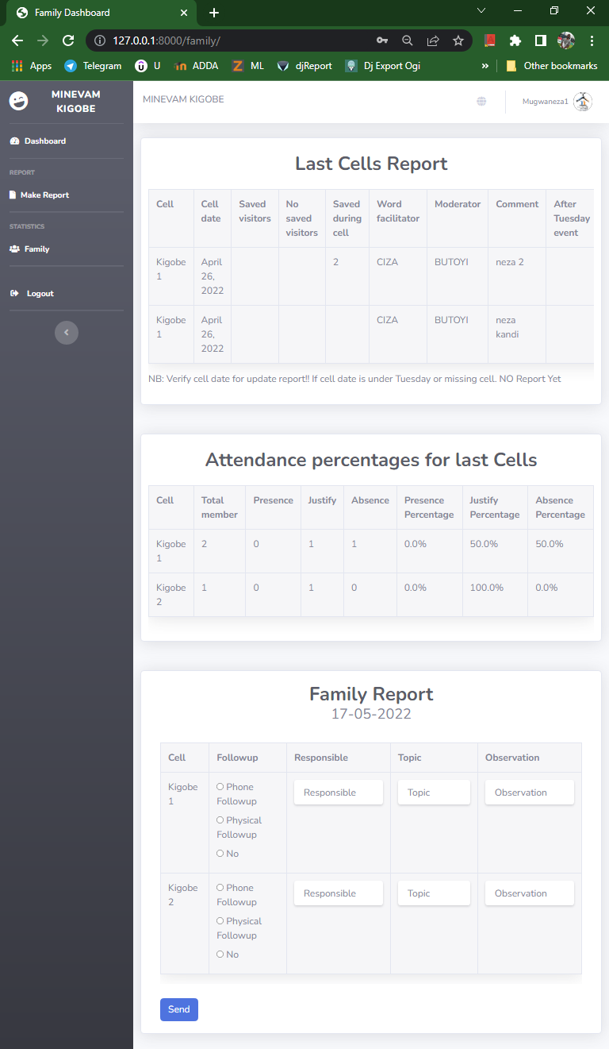

Figure 11: Family report

Figure below shows form for zone reporting of specific zone and analytics of each family that belong to the zone.

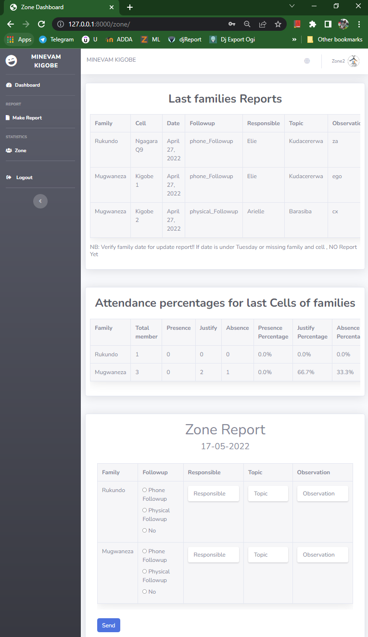

Figure 12: Zone report

Figure below shows form for district reporting and analytics of each zone that belong to the district.

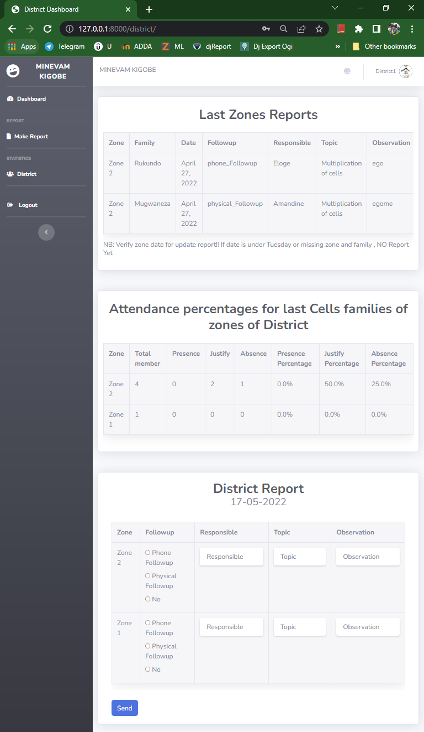

Figure 13: District Report

Figure below shows admin dashboard that contain analytics of the church and different management at the side bar.

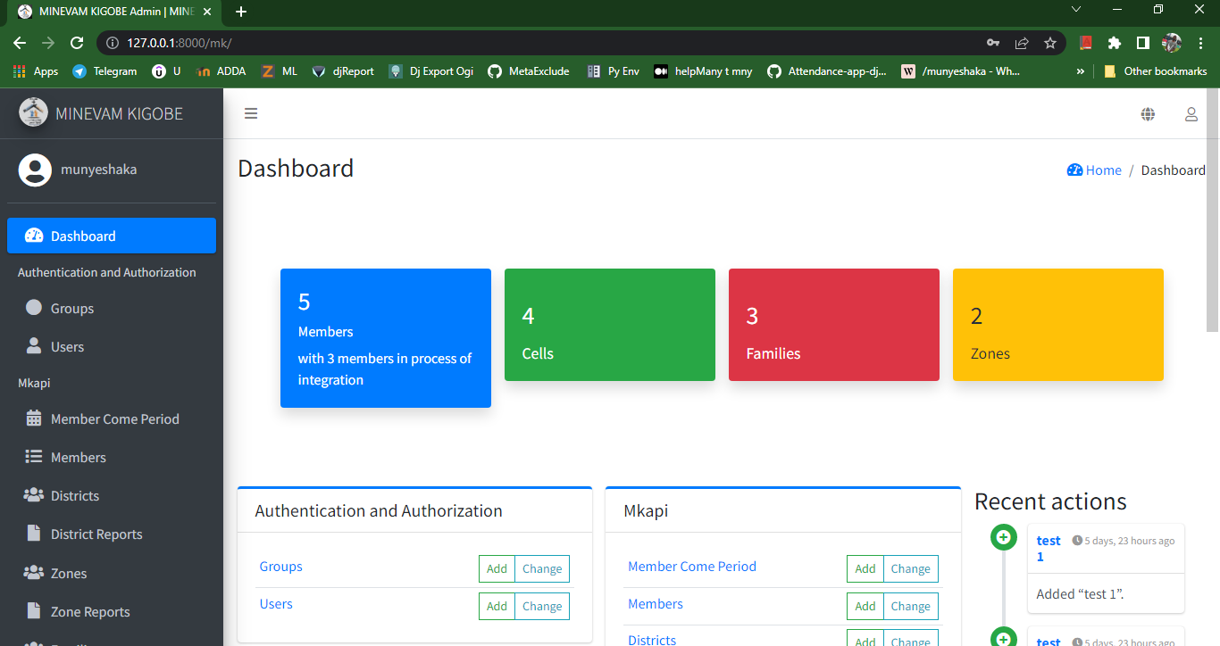

Figure 14: Admin dashboard

Figure below shows list of users with different permissions.

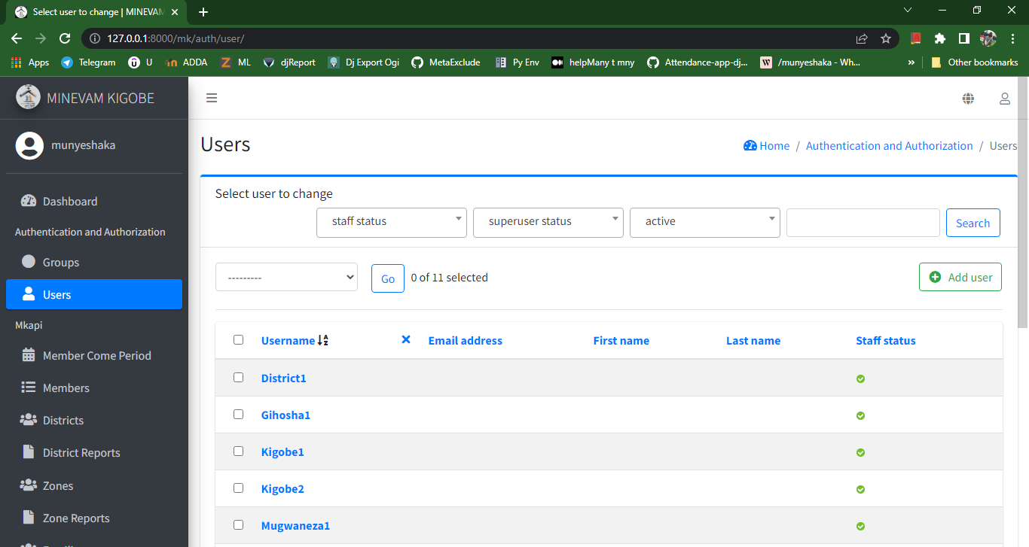

Figure 15: List of users _ admin side

Figure below shows list of periods of new members when they came in the church or (promotion).

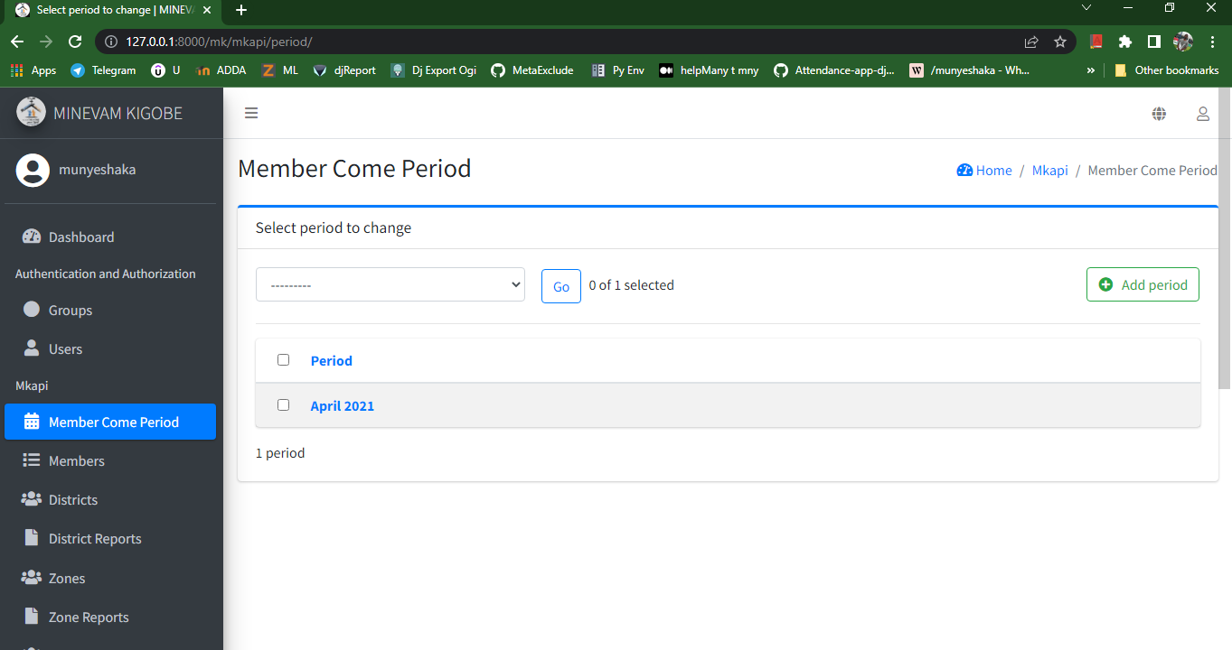

Figure 16: List of come period of new member (promotion)

Figure below shows list of all members, we can filter by period, cell and by family.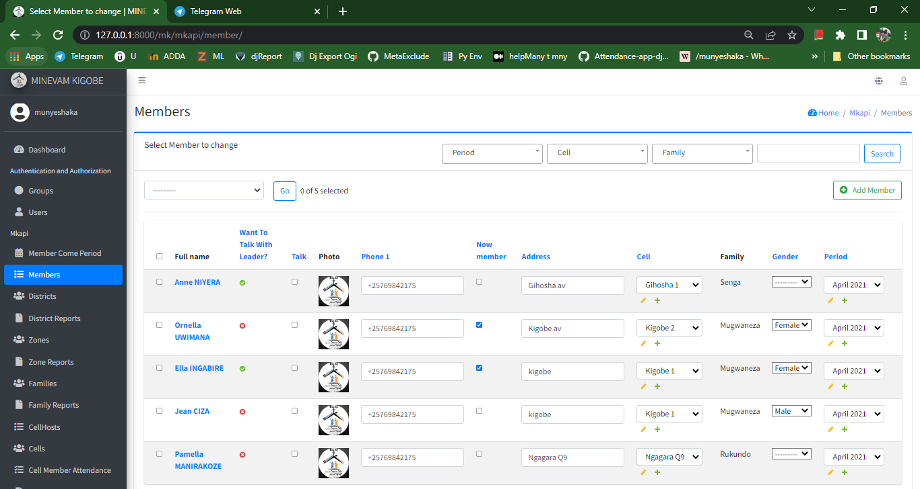

Figure 17: List of members

Figure below shows form of create district.

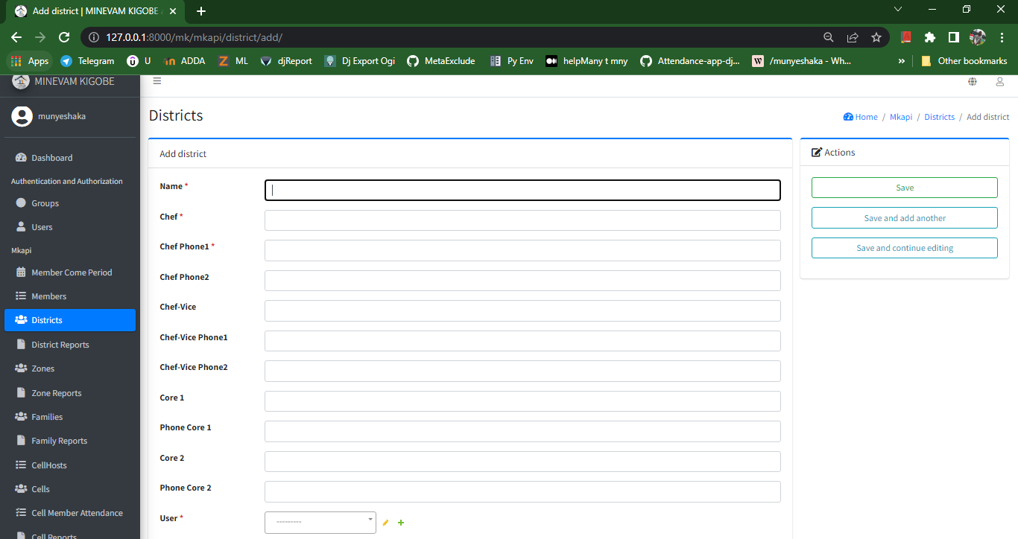

Figure 18: Form of add district

Figure below shows list of districts and different attributes.

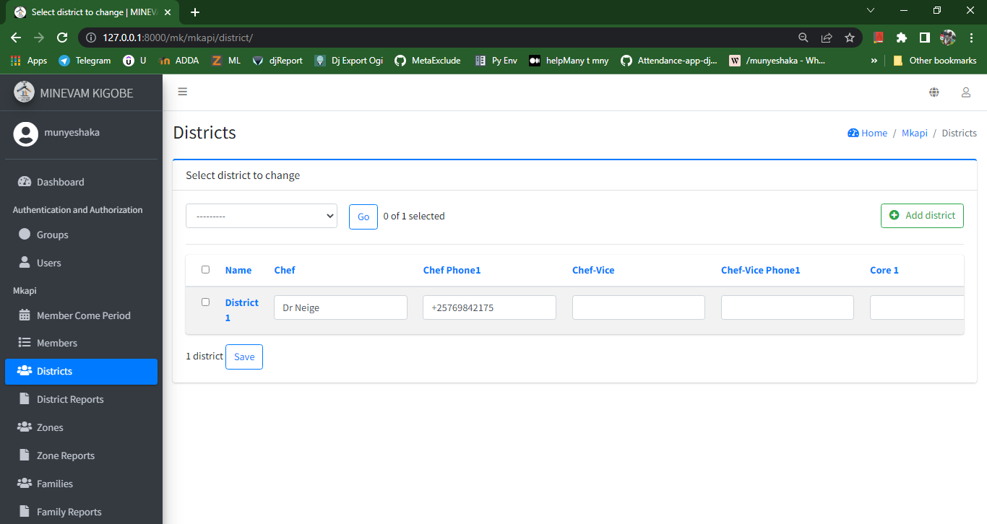

Figure 19: List of districts

Figure below shows form of change district.

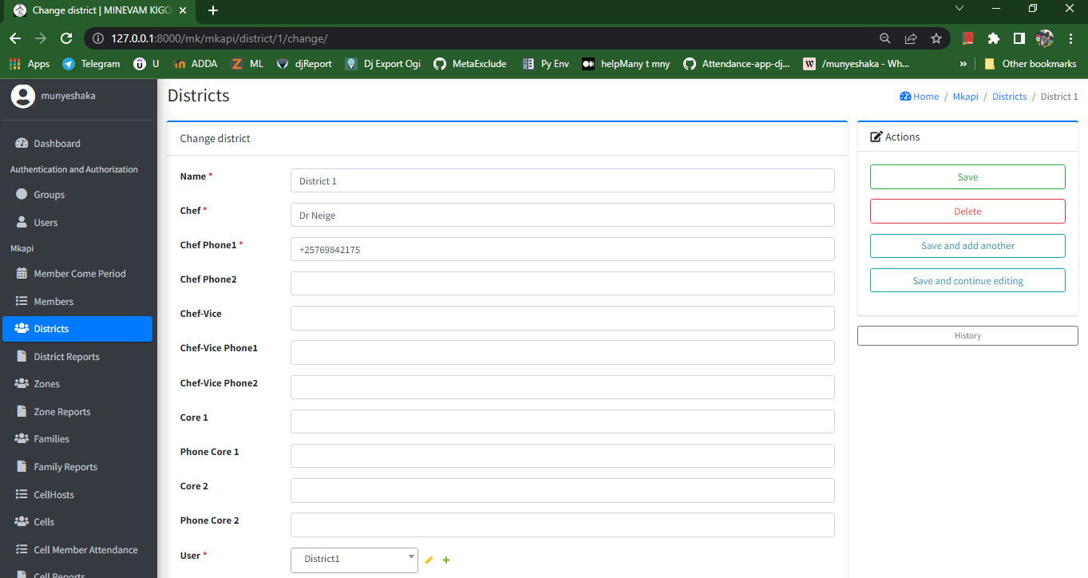

Figure 20: Form of change district

Figure below shows delete district page; we can delete district if we are sure

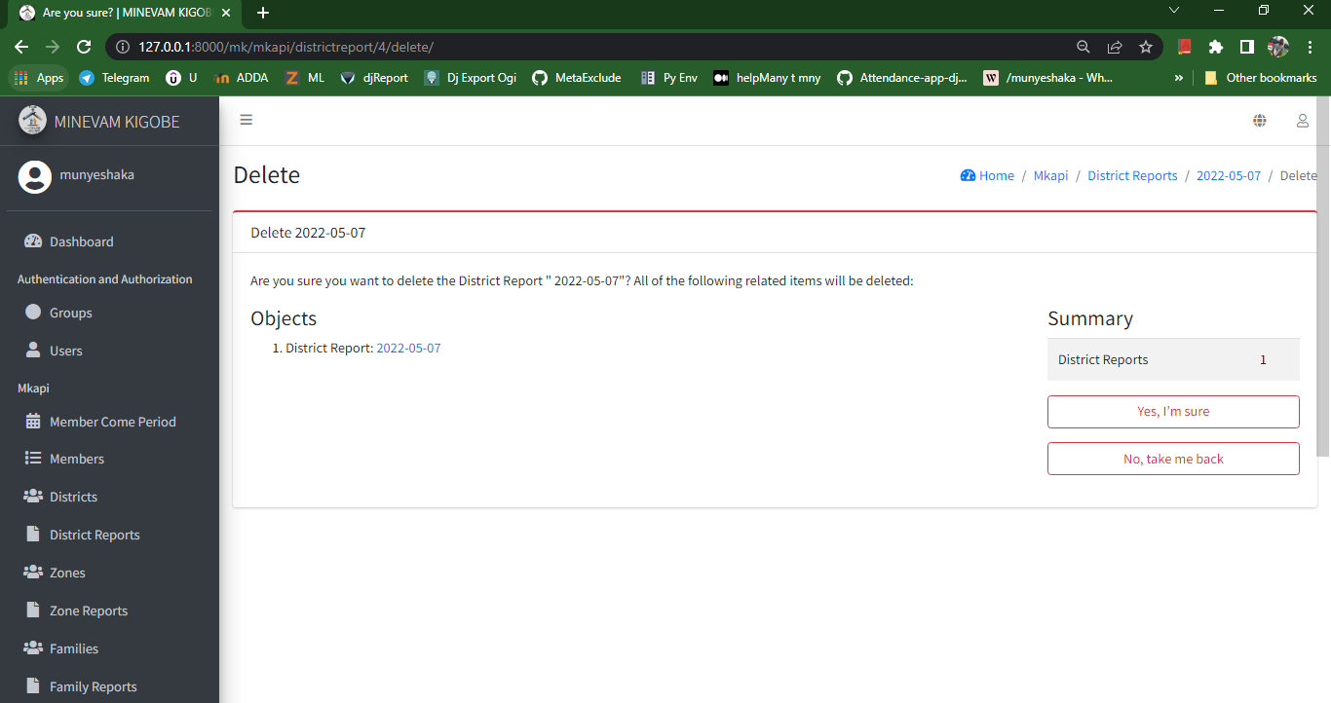

Figure 21: Delete district

Figure below shows list of district report, we can filter by district, zone and date.

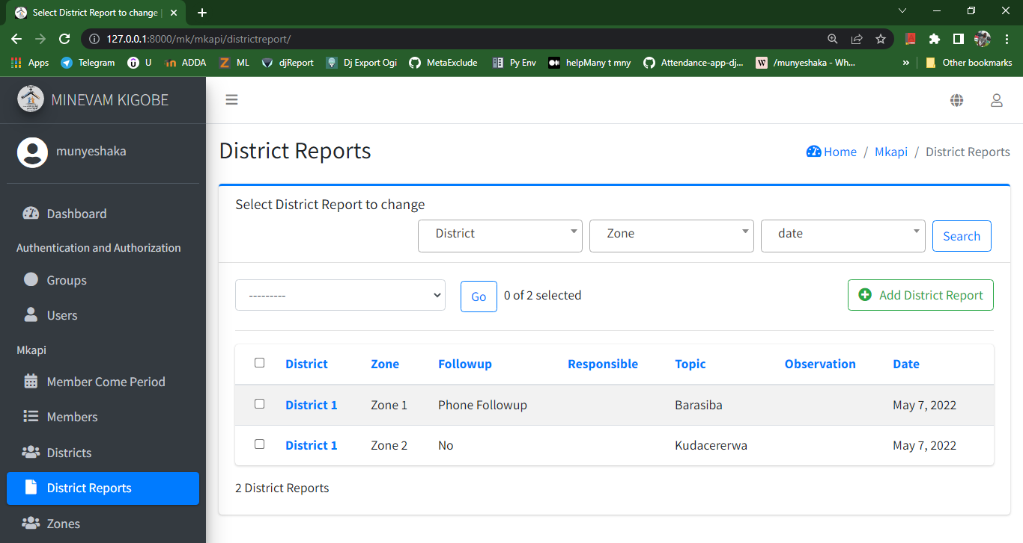

Figure 22: list of district report

Figure below shows list of zones and different attributes

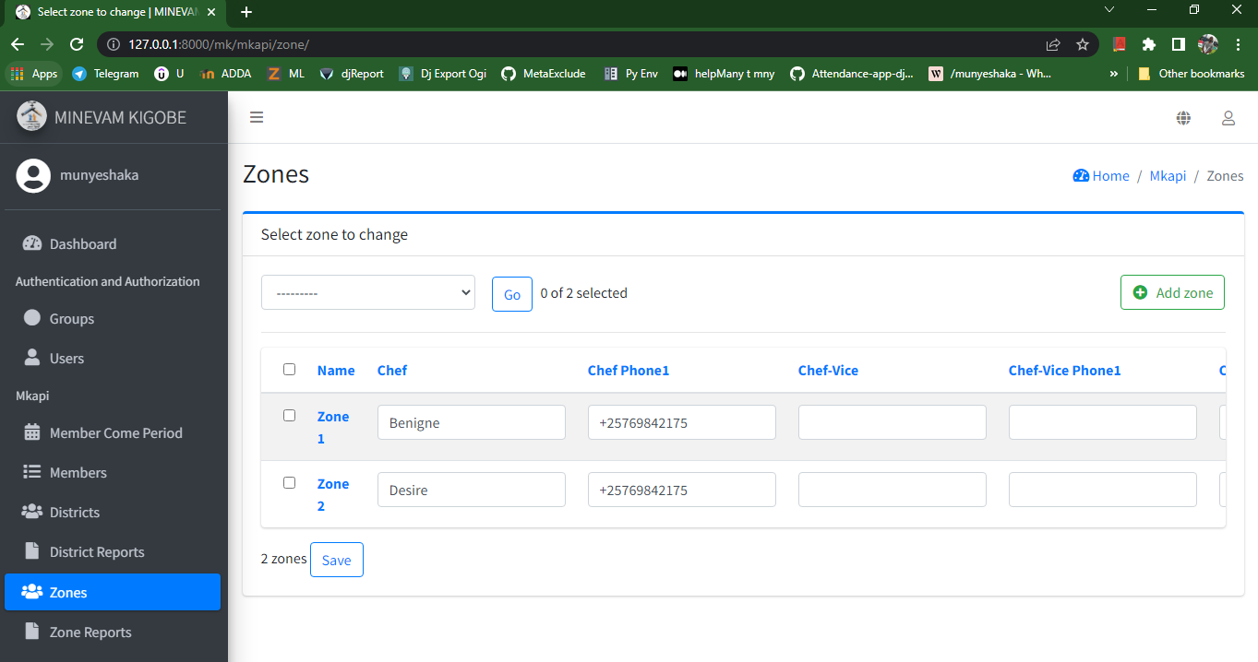

Figure 23: List of zones

Figure below shows list of zone report, we can filter by zone, family and by date.

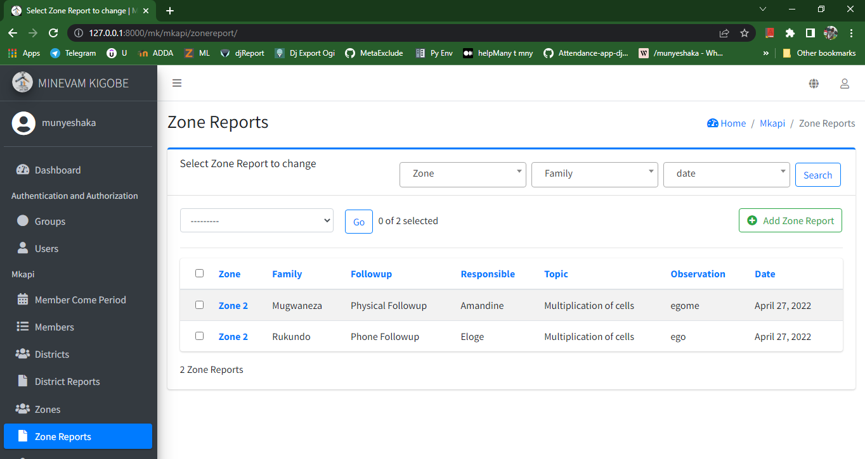

Figure 24: List of zone report

Figure below shows list of families and different attributes

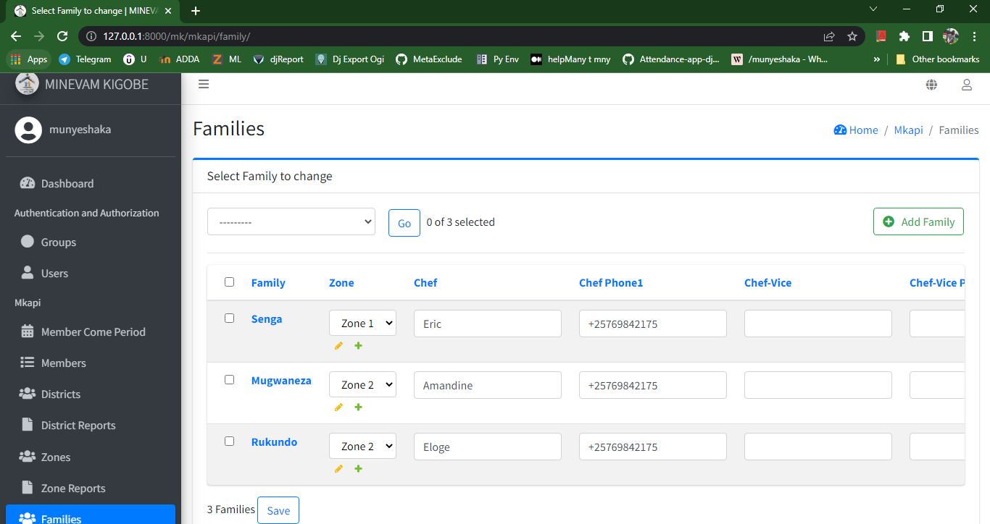

Figure 25: List of families

Figure below shows list of family report, we can filter by family, cell and by date.

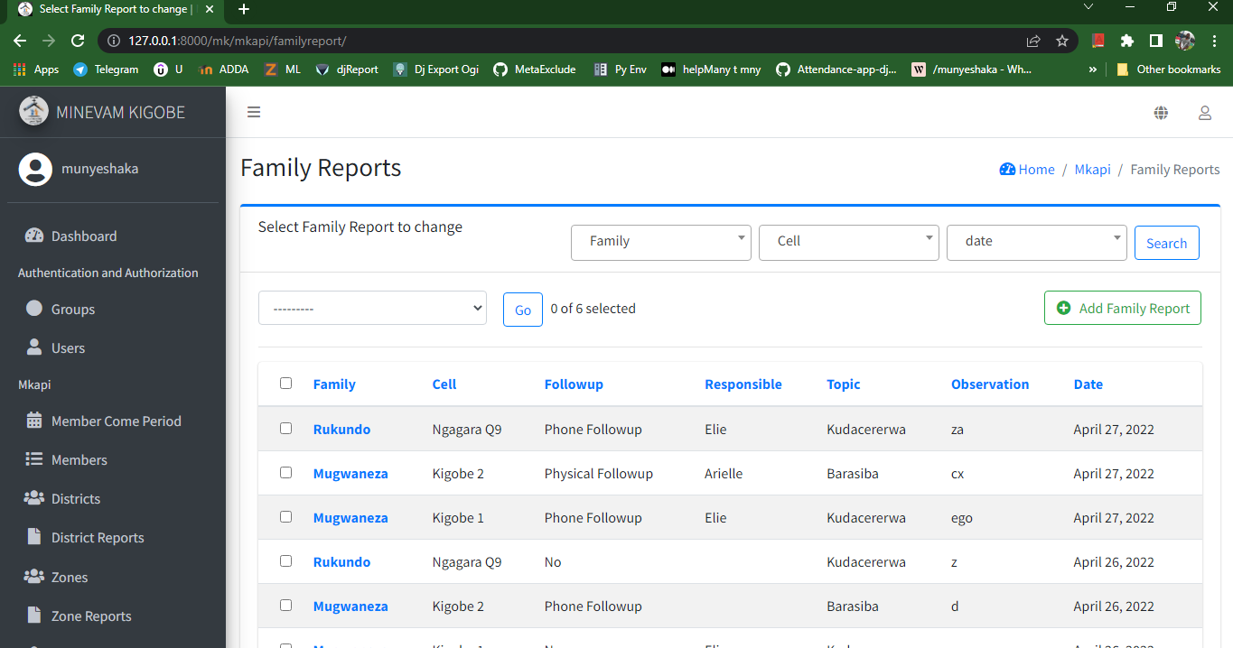

Figure 26: List of family report

Figure below shows list of cell host

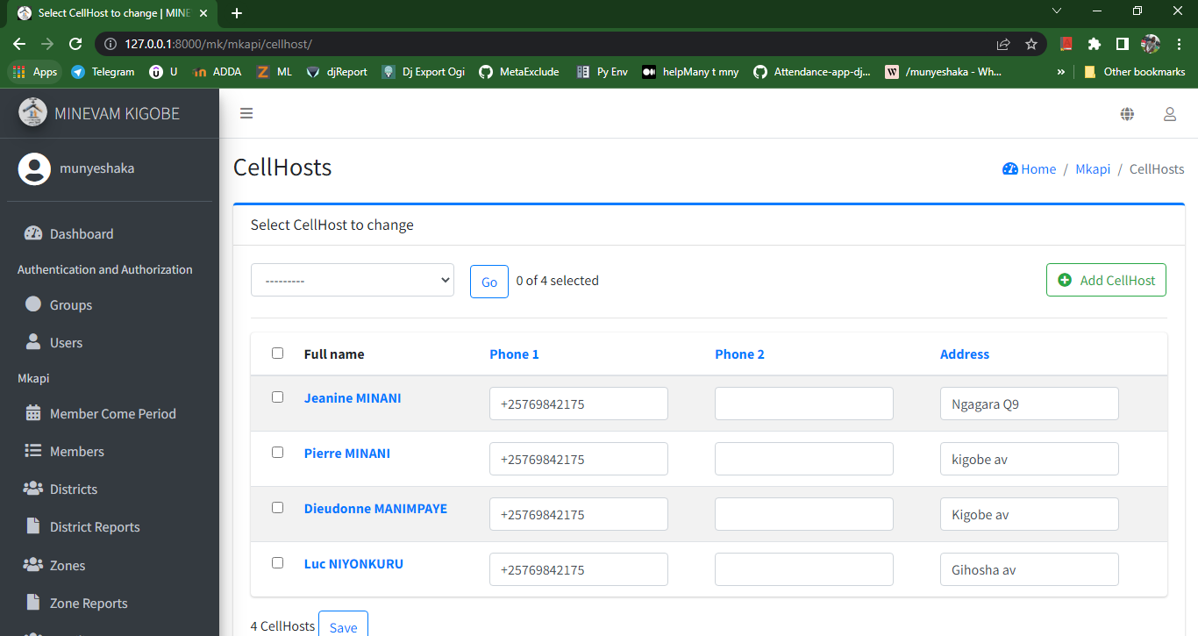

Figure 27: List of cell host

Figure below shows list of cells and different attributes

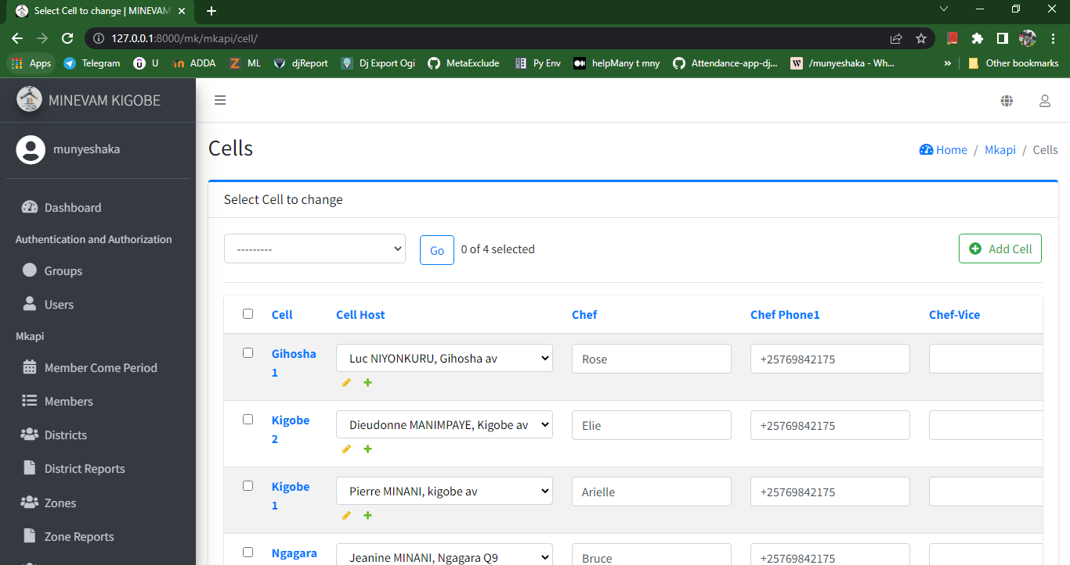

Figure 28: List of cells

Figure below shows list of cell member attendances for all cell; we can filter by cell, cell date and by family.

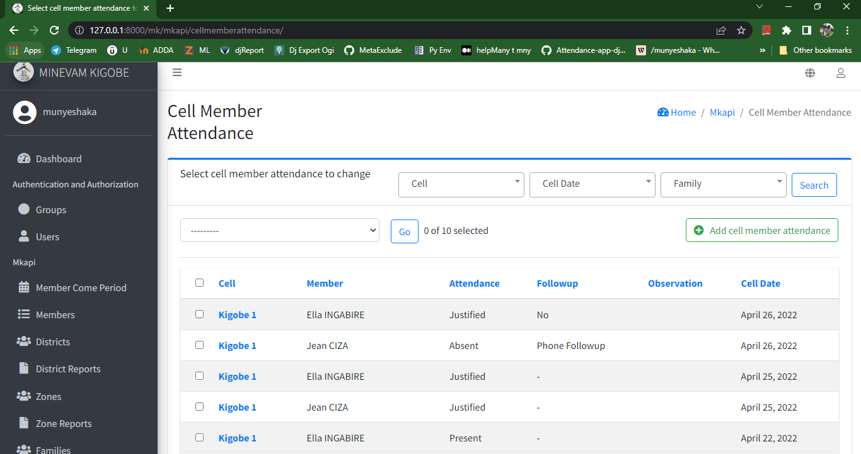

Figure 29: List of cell member attendances

Figure below shows list of all cell report; we can filter by family, cell and by cell date.

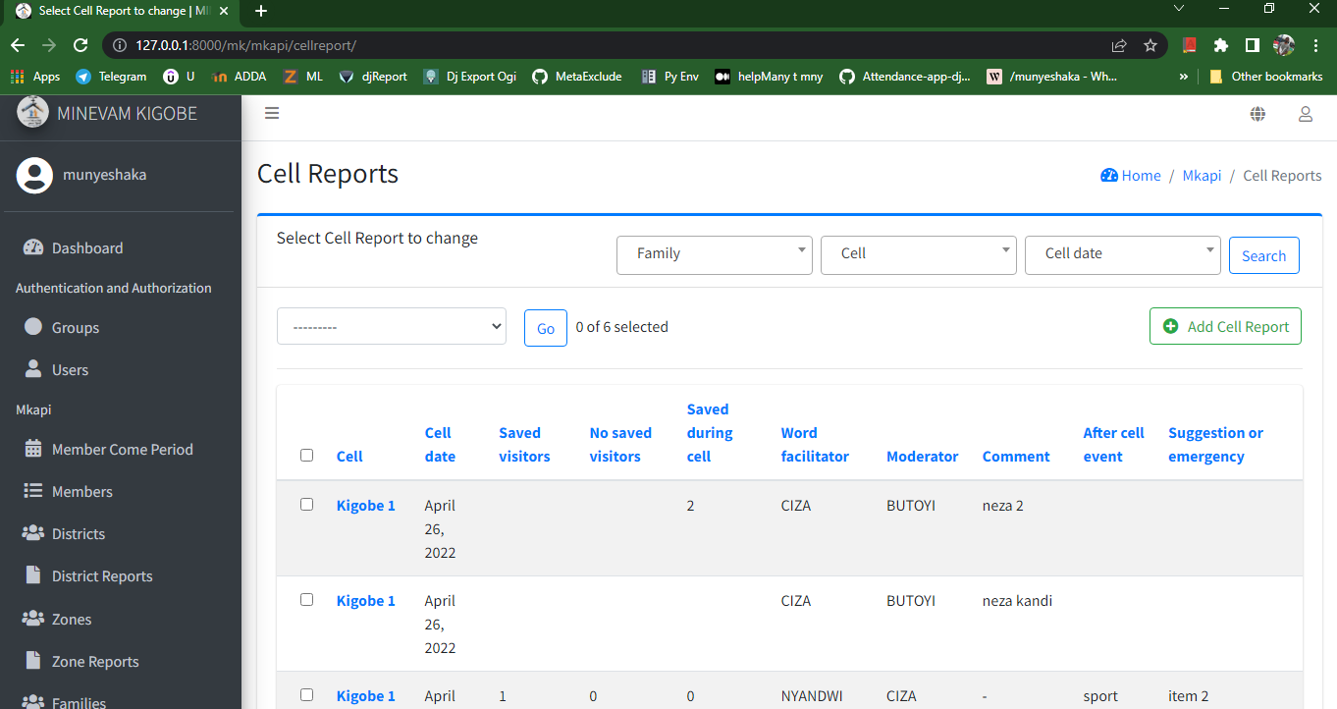

Figure 30: List of cell report

Figure below shows list of income of the church

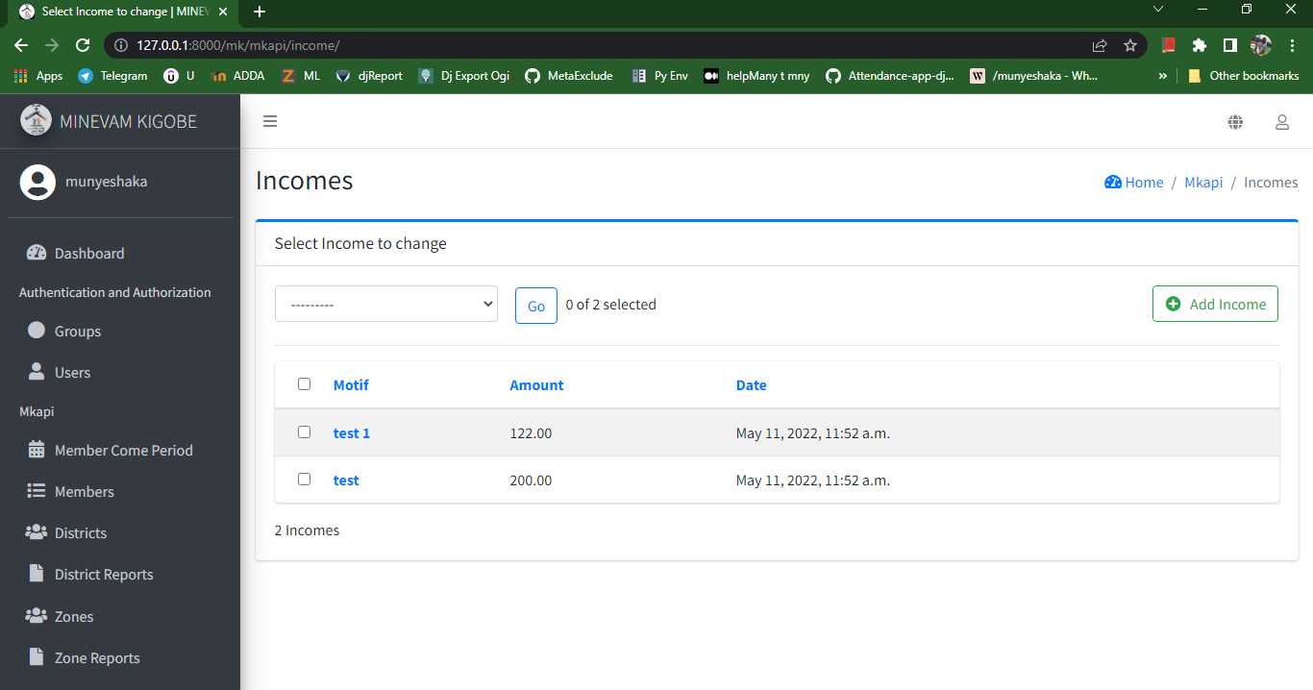

Figure 31: List of income

Figure below shows form add income of the church

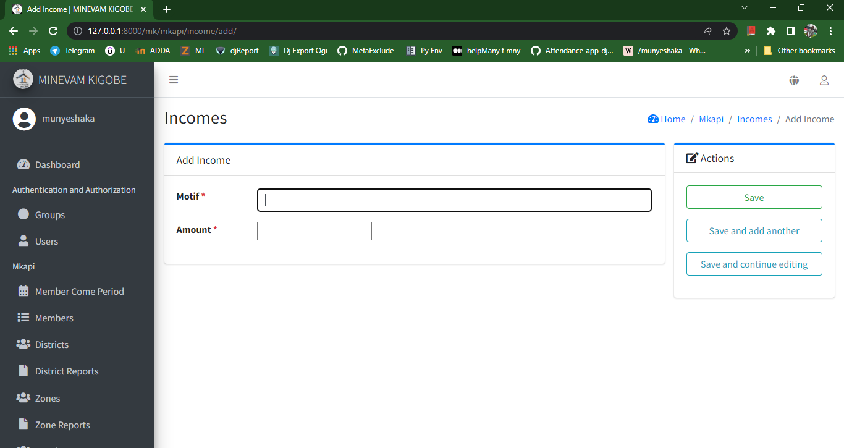

Figure 32: Form of add income

Figure below shows form of change income of the church

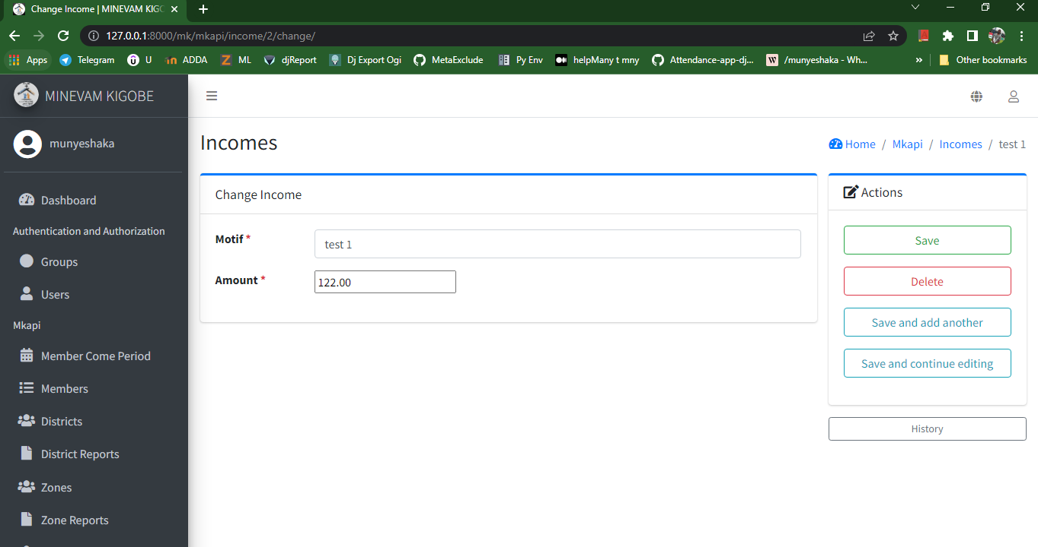

Figure 33: Form of change income

Figure below shows delete income page and button of confirmation.

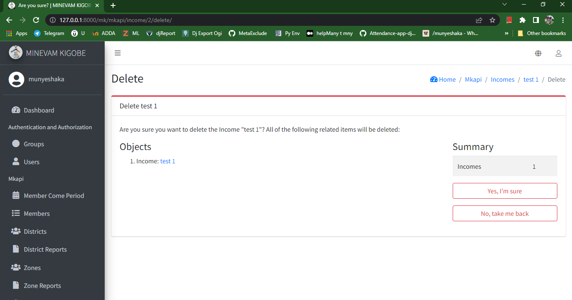

Figure 34: Delete income

Figure below shows list of outcomes of the church.

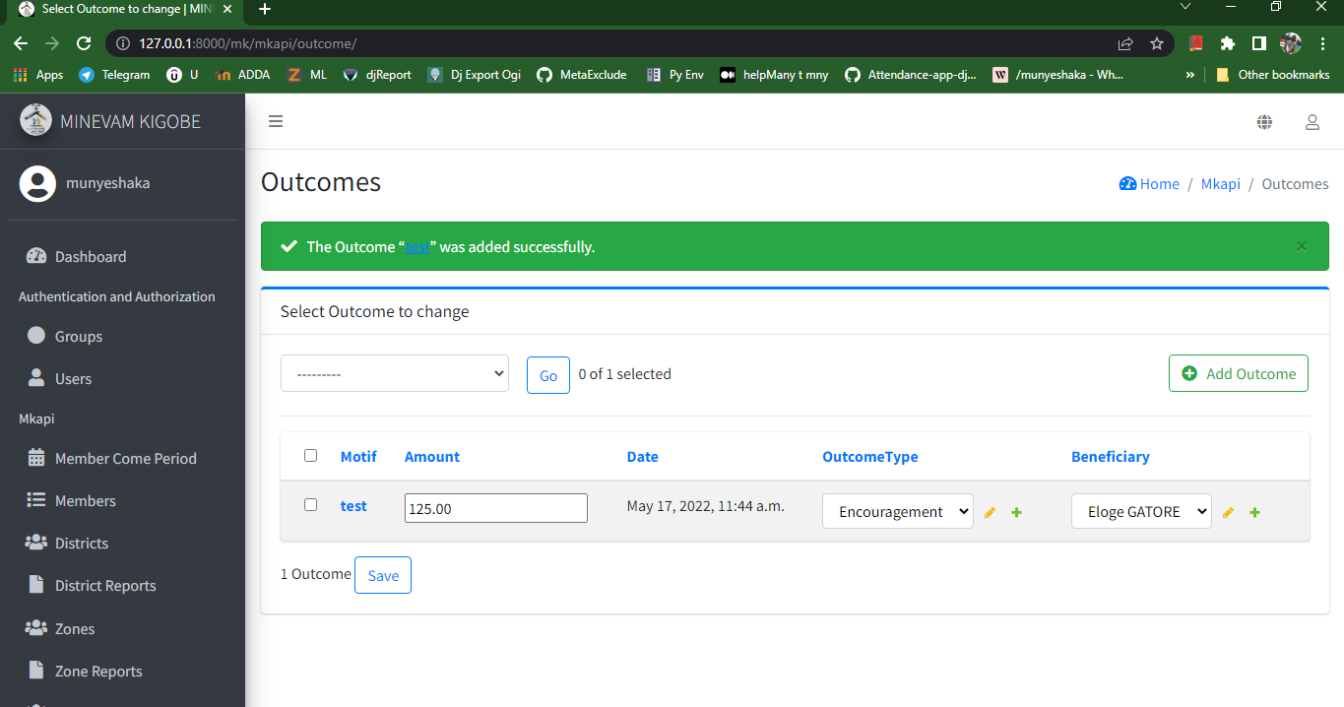

Figure 35: List of outcomes

Figure below shows list of beneficiaries of the outcomes

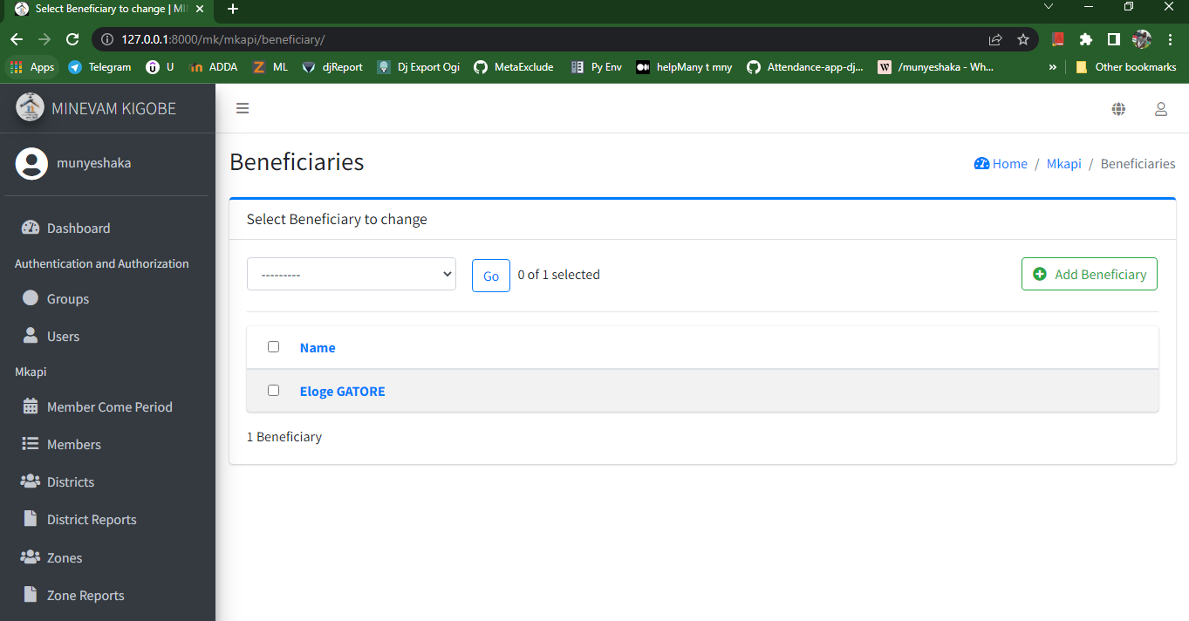

Figure 36: List of beneficiaries

Figure below shows list of outcome type

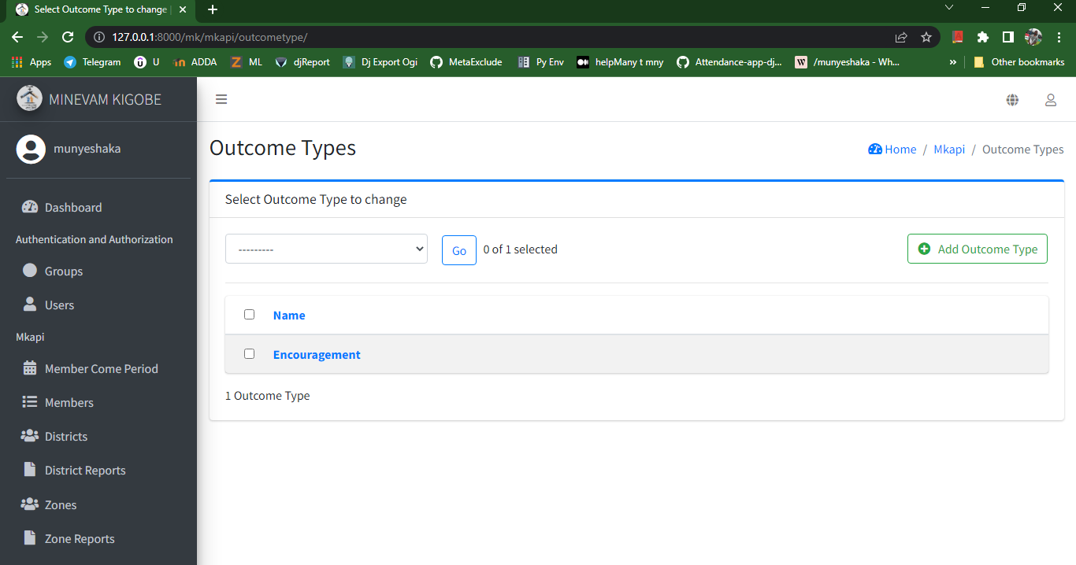

Figure 37: List of outcome type

Figure below shows list of all departments of the church; we can filter by category, objective.

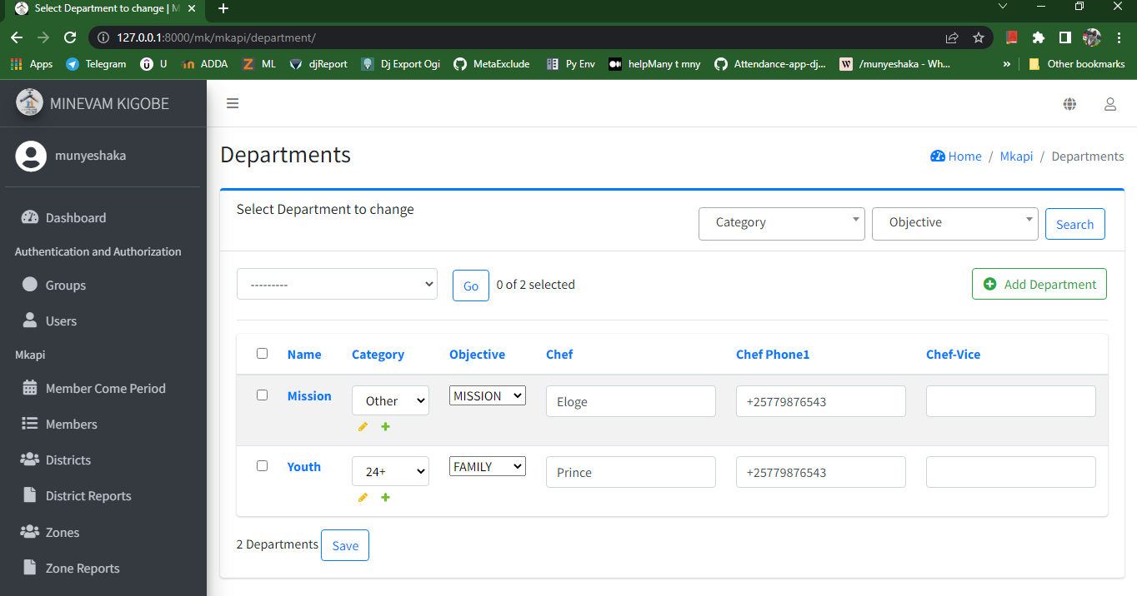

Figure 38: List departments

Figure below shows list of department members; we can filter by department, cell, family and by category.

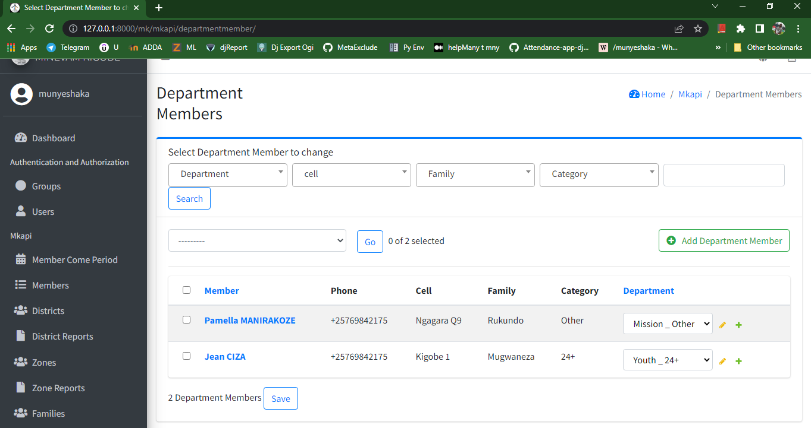

Figure 39: List of department members

Figure below shows list of categories for all small groups of the church

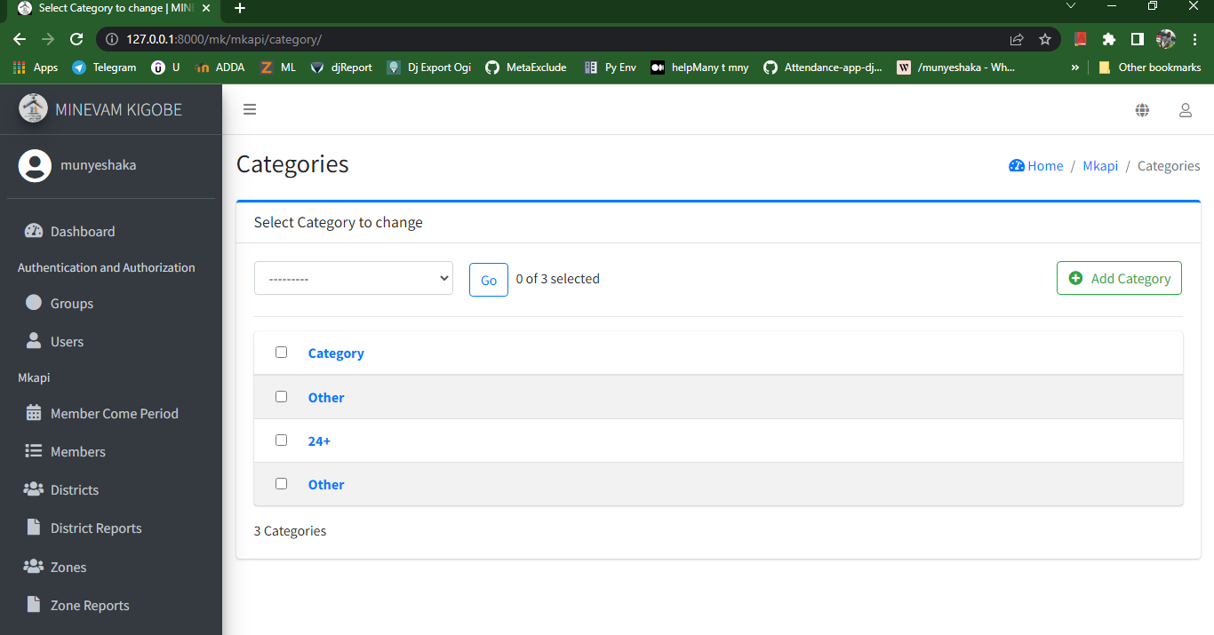

Figure 40: List of categories

### **IV.5.3 Advantages of application**

This application will help the church to know its management in real time and will help to take decisions. This application will help leaders to get data: list of members for different cells, family, zone and district, for different department and will help to get list of leaders: cell, family, zone, district.

Reporting cell activity will be very easy and direct to the system, everywhere, every time.

# **CHAPITRE V: GENERAL CONCLUSION AND SUGGESTIONS**

## **V.1. General conclusion**

### **V.1.1. Critical assessment of the progress of the internship**

My internship in MINEVAM Kigobe church was very wonderful, I do understand the information system easily with existing system. Stack that I had it was about cell reporting member attendance: it was very difficult to manage it from paper to dynamic functionality; another struggle was to manage difference users for difference interfaces (permission between user).

### **V.1.2. Critical appraisal of the observed problem**

I didn’t get a problem according analysis of the data collected because it was very clear, they have paper forms it was just digitalize the system, the problem was to get data in real time.

## **V.2. Suggestions**

MINEVAM Kigobe may have web application for church growth in real time and reporting cell activity because cell leaders, family leaders, zone leaders and districts leaders will send report from everywhere and will be stored directly in the system and the church leaders will make very quickly decision.

# **REFERENCES**

[1] UML use case: <https://creately.com/blog/diagrams/use-case-diagram-relationships/> retrieved February 7th, 2022

[2] Sequence diagram <https://creately.com/blog/diagrams/sequence-diagram-tutorial/> retrieved February 9th,2022

[3] Class diagram: <https://creately.com/blog/diagrams/class-diagram-relationships/> retrieved 10th February 10th, 2022

[4] Activity diagram: <https://creately.com/blog/diagrams/activity-diagram-tutorial/> retrieved September 9th, 2022

[5] MINEVAM history: <https://minevam.com/> retrieved May 9th, 2022

[6] Advantages of UML: <https://creately.com/blog/diagrams/advantages-and-disadvantages-of-uml/> Retrieved September 9th, 2022

[7] Manual from organization

[8] Login post rest api: <https://stackoverflow.com/questions/48012447/django-transforming-form-data-to-rest-api-post-request>

[9] Why REST API: <https://medium.com/@shivansht9211/build-a-todo-api-in-django-rest-framework-12105cc8e709> retrieved February 14th, 2022

[10] Explanation of choice of UML: <https://miro.com/blog/uml-diagram/#:~:text=UML%20is%20used%20to%20create,not%20limited%20to%20software%20developers>. Retrieved September 9th, 2022

[11] Django Software Foundation: <https://www.djangoproject.com/>

[12] Bootstrap 5: <https://getbootstrap.com/docs/5.0/getting-started/introduction/>

[13] WampServer: <https://www.wampserver.com/en/>